Intelligent puzzle solution process using swarm intelligence

*Abstract*— This paper introduces Ant Traversing Method (ATM), an optimized searching method that is implemented to the typical 9X9 sudoku puzzle problem. In ATM a set of intelligent ant called ant agents are introduced to find the optimal solution for Sudoku puzzle. Agents work independently to find the result. Final outcome is obtained based on the amount of pheromone deposited by the ant agent on the target cell of the matrix. Each ant agent starts their journey from each vacant cell of the Sudoku matrix. Agents deposit pheromone in the form of digit to the starting cell after completing the tour along the predefined path. Efficiency and optimality of ATM are examined by undergoing through experiments to evaluate the operation. It is found that performance of ATM is satisfactory with compare to the typical backtracking method for solving typical sudoku puzzle.

Keywords— Sudoku Puzzle problem, Swarm Intelligence, Ant Colony Method, Agent, Ant Traversing, Puzzle Optimization.

# Introduction

A sudoku problem is a number based puzzle problem [1][2]. A typical Sudoku problem consists of a 9X9 matrices having few cells filled by digits 1 to 9, and rest of the cells are vacant. Objective is to fill the vacant cells in such a manner that there will be no row-wise or column-wise repetition of digits. Minimum number of clues required to solve a Sudoku is 17[3]. A 9X9 matrix is subdivided into 9 3x3 sub-matrices. There should not be any repetition of digits in the sub-matrix too. Different variations of Sudoku based on the matrix size are introduced in different part of the world.

Backtracking method is used to solve typical Sudoku puzzle [4]. Backtracking approach is typically a brute force method. It visits the vacant cells of the matrices, fill them with some digits. If the filled digits are found invalid as per the rule of the puzzle then the digit will be discarded and another digit will be placed [5][6][7][8]. Major drawback of this method is the time complexity.

Ant colony optimization algorithm is swarm intelligence method to solve computational problem. This method is inspired by the food hunting and searching method of the real ants. The pheromone based method is used as an intelligent and automatic replacement of tracking procedure in computational field. Ant behavior inspired different algorithms are already implemented in different sector by replacing the natural pheromone of ant by chemical or physical ways [9][10].

Nature inspired algorithms are implemented to in puzzle solving areas to reduce the time complexity by researchers. Travelling sales person problem is solved by implementing Ant Colony Optimization method. Ants are considered as agent. Shortest path from source to source after reaching all cities is found by the agent [11]. Artificial Bee Colony algorithm is implemented in [12] to solve Graph Coloring problem.

# Proposed Work

## Swarm based Sudoku Puzzle Solution

ATM is introduced in this paper to find an optimal solution for a typical 9X9 Sudoku puzzle. This method is different from the typical backtracking based Sudoku Puzzle solution in three main aspects: i) An optimized solution is yielded based on in depth feasibility study performed by Ant Agent, ii) Reduction of wastage of effort as no backtracking concept is followed, iii) minimum number of changes are made to the values of one cell with compare to backtracking method and iv) A complete solution is proposed as pre-implemented survey is performed about the appropriate placement of the digits.

Informally ATM works as follows: ‘n’ number of ant agents start their journey from the vacant cells, ‘n’ is the number of vacant cells that to be filled by the appropriate digits. Each ant agent is having nine types of pheromone, representing all digits from 1 to 9. Ant traverses along all the cells of the corresponding row, column and sub-matrix. Ant deposits pheromones of the digits that are not found in the path from the starting cell to the end cell in the particular path into the starting cell as depicted in the Fig. 1.

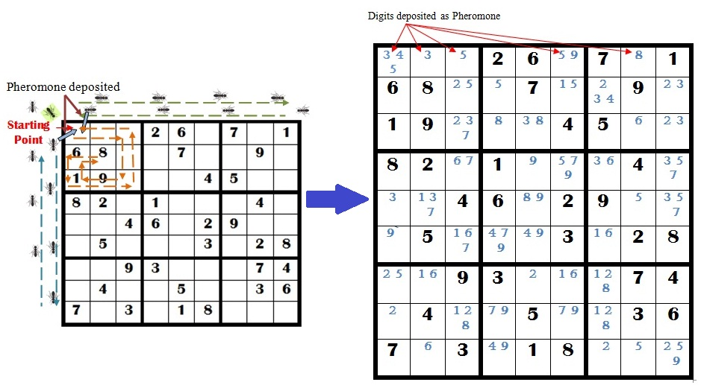

Figure 1. Implementation of ATM in a typical 9X9 Sudoku Puzzle

Ant agents start their journey from cells chosen according to some initialization rule (e.g. randomly or previously visited cell). Each agent starts a repetitive tour by applying some stochastic greedy approach for each empty cell of the Sudoku matrix. An agent changes the pheromone secretion mechanism based on the encountered digits by applying Pheromone Elimination process (PE). Once all cells of the predefined path of the agent are traversed, the selective digits in the form of pheromones will be deposited on the originating cell. Empty cells that are having a single probable digit will be filled first. Ant agent starts the same tour for every empty cell to find the candidate digits in the form of pheromone.

In contrary to typical ant system ant agent has to follow a predefined fixed route for every traversal. Ant pheromone is used here to indicate the probable digits in each cell. A cell with minimum amount of pheromone will be filled first as number of candidate digits minimum hence minimal selection option will be there.

The Pheromone Elimination(PE) method is designed in such a manner that each time the ant agent is finding a digit in its traversing path, corresponding pheromone secretion will be closed unless it reaches it’s origin. The PE method is depicted in Algorithm 1.

|  |
| --- |
| Algorithm 1: Pheromone_Elimination (ph[9], p) |
| Input:  Total Pheromone of Ant Agent  Pheromone found in a cell |
| Output:  Pheromone available in the Ant Agent after traversing the allotted path |
| Data structures used:  ph[9]:= It is a 1-D array, used for storing the 9 types of pheromone representing digits from 1 to 9;  p:= It is a variable, it stores the pheromone found in the corresponding cell of the Sudoku matrix;  n:= Number of rows of the Sudoku matrix=Number of columns of the Sudoku matrix  m[n][n]:= It is a 2-D array, used to represent a (nXn) Sudoku matrix |
| Step 1: Start  Step 2: For i:=1 to n  For j:=1 to n repeat Step 3.  Step 3: Repeat for k:=1 to 9  if (ph[k]=m[i][j])  then  ph[k]:= DELETED  Step 4: for i:=1 to n  Display ph[i].  Step 6: Exit. |

The ATM differs from the conventional ant colony process in three main aspects: i) Each ant agent is carrying 9 types of pheromone in the form of digit 1 to 9, ii) Pheromone of the ant agent will be locked if it encounters the same pheromone in it’s traversed path, and iii) After traversing along three paths ant agent will deposit unlocked pheromone onto the source cell.

# Experimental Result

In this section, ATK concept is implemented on Sudoku problems of different degree of toughness. The result is compared with conventional backtracking method of Sudoku solving techniques in terms of time, number of times value of one cell is overwritten. Our proposed method is implemented using C language on a Notebook PC with CPU 2.66 GHZ.

Two types of sudoku problems based on the hardness are considered. The results are summarized and compared in Table I. In the Table, |V| denotes the number of clues in the puzzle and “T” denotes the number of times values are changed. It is noted that Table I contains the average of 10 runs in each case.

TABLE I. TIME CONSUMPTION OF THE ABC-GCP

|  |  |  |  |  |  |
| --- | --- | --- | --- | --- | --- |
| *|V|* | *Hardness* | *ATM* | | *Backtracking* | |
| *T* | *Time* | *T* | Time |
| 28 | Medium | 504 | 0.008 | 1482 | 0.008 |
| 29 | 1939 | 0.008 | 1939 | 0.008 |
| 29 | 1985 | 0.012 | 1985 | 0.008 |
| 29 | 583 | 0.006 | 796 | 0.007 |
| 30 | 0 | 0.006 | 713 | 0.007 |
| 22 | Hard | 137212 | 0.085 | 138156 | 0.085 |
| 23 | 1202 | 0.004 | 3207 | 0.010 |
| 24 | 575 | 0.007 | 79609 | 0.061 |
| 25 | 529 | 0.008 | 882 | 0.008 |
| 26 | 11603 | 0.015 | 13418 | 0.016 |

Comparative analysis of execution time between ATM and backtracking method for Sudoku solving is pictorially represented in Fig. 2.

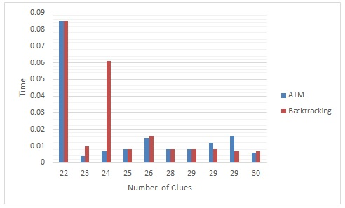

Figure 2. Execution Time comparison between ATM and Backtracking

In typical backtracking method cell value would be changed many times with compare to our proposed method as shown in Fig. 3.

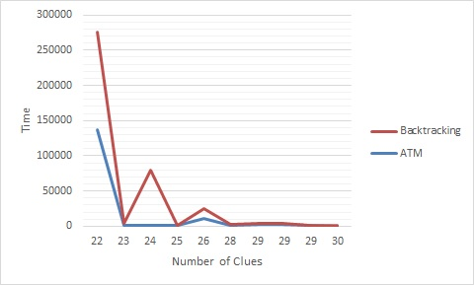

Figure 3. Comparison of number of times value of a cell is changed

# Conclusion

ATM method is proposed for solving typical Sudoku puzzle solving. We focus on the time consumption to solve the puzzle successfully and number of failed attempt to insert a digit in appropriate place. Ant Traversing Method is introduced here to find out the most accurate candidate for an empty cell. Each ant is represented as an agent to dispense the appropriate pheromone in the form of digit at right place. In future, it may be possible to reduce the number of agents without hampering the efficiency of the process. A variation of the proposed method may be introduced to solve different puzzle based real time problems. It can be concluded that the proposed ATM would be beneficiary for solving different computational problems.

##### References

1. Arnoldy, Ben. "Sudoku Strategies". The Christian Science Monitor.
2. Schaschek, Sarah (March 22, 2006). "Sudoku champ's surprise victory" The Prague Post. Archived from the original on August 13, 2006. Retrieved February 18, 2009.
3. Royle, Gordon. "Minimum Sudoku" Retrieved February 28, 2012
4. http://intelligence.worldofcomputing/brute-force-search Brute Force Search, December 14th, 2009
5. "Backtracking - Set 7 (Sudoku)" GeeksforGeeks. GeeksforGeeks. Archived from the original on 2016-08-28. Retrieved 24 December 2016.
6. Norvig, Peter. "Solving Every Sudoku Puzzle" Peter Norvig (personal website). Retrieved 24 December 2016.
7. "Chart of Cells Visited for Solution" A chart showing a solution path to a difficult Sudoku.
8. Zelenski, Julie (July 16, 2008). Lecture 11 | Programming Abstractions (Stanford) Stanford Computer Science Department.
9. Russell, R. Andrew. "Ant trails-an example for robots to follow?" Robotics and Automation, 1999. Proceedings. 1999 IEEE International Conference on. Vol. 4. IEEE, 1999.
10. Fujisawa, Ryusuke, et al. "Designing pheromone communication in swarm robotics: Group foraging behavior mediated by chemical substance" Swarm Intelligence 8.3 (2014): 227-246.
11. Dorigo M., Gambardella L. M.. “Ant Colony System: A Cooperative Learning Approach to the Travelling Salesman Problem”, IEEE Transactions on Evolutionary Computation, Volume 1, Number 1, pp. 53-66, 1997.
12. Dorrigiv M., Markib H. Y., “Algorithms for the Graph Coloring Problem based on Swarm Intelligence”, The 16th CSI International Symposium on Artificial Intelligence and Signal Processing (AISP 2012), Fars, Iran, pp. 473-478, 2012.